ALLERGEN CONTENT – SF PARKS LTD– GOLDEN GATE & JAKES BAR (** According to Manufactures Guide)

Ice cream toppings | 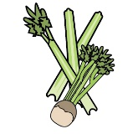 | 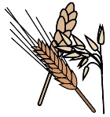 | 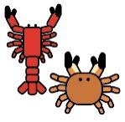 |  | 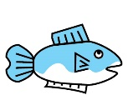 | 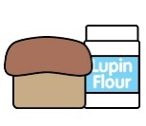 | 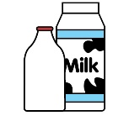 |  | 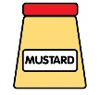 | 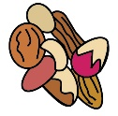 | 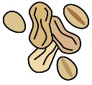 | 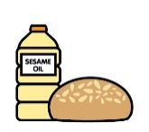 |  | 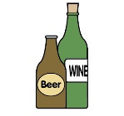
 | Celery | Cereals containing gluten | Crustaceans | Eggs | Fish | Lupin | Milk | Mollusc | Mustard | Nuts | Peanuts | Sesame seeds | Soya | Sulphur Dioxide
Caramel Fudge Mini Cubes
ONLY
Cookie Pieces Digestive  ONLY |  | GLUTEN
Rolo Mini Bulk Topping  ONLY |  | GLUTEN
Salted Caramel Chips
ONLY
99 Chocolate Flakes Cadbury
ONLY
Smarties Mini Topping  ONLY |  | GLUTEN
OTT Belgian Chocolate Dessert Topping

OTT Salted Caramel Dessert Topping
OTT Strawberry Dessert Topping
Soft ice cream  AND CONE  ONLY |  | GLUTEN
Ice cream toppings & DESSERT
 | Celery | Cereals containing gluten | Crustaceans | Eggs | Fish | Lupin | Milk | Mollusc | Mustard | Nuts | Peanuts | Sesame seeds | Soya | Sulphur Dioxide
WAFFER CONE  ONLY |  | GLUTEN
MINI DOUGHNUTS  ONLY |  | GLUTEN
LA BO  CHOCOLATE  BROWNIE  ONLY |  | GLUTEN |  |  |  |  |  |  |  | MAY | MAY
DEEP FRIED APPLE PIE  ONLY |  | GLUTEN
MARSHMALLOWS
MALTESER |  | BARLEY  GLUTEN  WHEAT
SMARTIES |  | GLUTEN  WHEAT
MARS BAR |  | BARLEY GLUTEN |  |  |  |  |  |  |  | MAY | MAY
MILK SHAKE
MILK AND ICE CREAM ONLY

 | Review date: |  | 20.4.24 |  |  |  | Reviewed by: |  | M J W GIBBON, N ROBERTS |  |  |  |  |  |  | 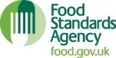 |  | You can find this template, including more information at www.food.gov.uk/allergy
Smoothies
 |  | Celery |  | Cereals containing gluten | Crustaceans | Eggs |  | Fish |  | Lupin | Milk | Mollusc | Mustard | Nuts | Peanuts |  | Sesame seeds |  | Soya | Sulphur Dioxide
AVO GO GO |  | NONE
BERRY GO ROUND |  | NONE
PASH n SHOOT |  | NONE
STRAWBERRY SPILT |  | NONE
&
Review date: | 20.4.24 | Reviewed by: | M J W GIBBON, N ROBERTS |  | You can find this template, including more information at www.food.gov.uk/allergy

